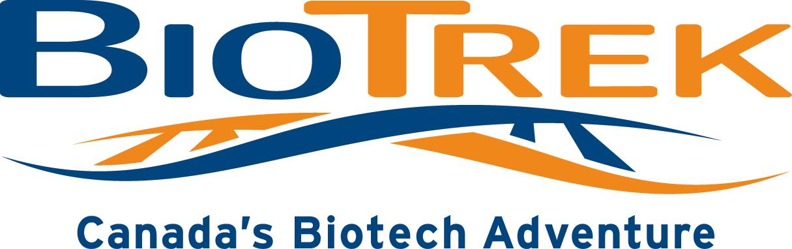

Toronto, July 16-20, 2007
Student Survey

1) How did you find out about BioTrek?

2) Please tell us which activity you liked most and which you liked least.

Liked Most Liked Least
Discussion about GM organisms
DNA extraction
Lambda DNA restriction digest
Discussion about PIGD
pGLO transformation
Discussion about DNA database
ELISA
PV92 PCR
Discussion about DNA sample provision
Visit to MaRS

3) Please tell us what you liked or disliked about the two activities you chose above.

4) The material was delivered at a level that was appropriate for my grade.

Strongly disagree Disagree Neither agree nor disagree Agree Strongly Agree

5) The material was delivered at a level that was appropriate for me in particular.

Strongly disagree Disagree Neither agree nor disagree Agree Strongly Agree

Please explain your answer.

6) I enjoyed using the equipment that was available to us.

Strongly disagree Disagree Neither agree nor disagree Agree Strongly Agree

7) The instructor kept me interested in the material.

Strongly disagree Disagree Neither agree nor disagree Agree Strongly Agree

8) The discussions made me think about issues in biotechnology.

Strongly disagree Disagree Neither agree nor disagree Agree Strongly Agree

9) BioTrek was a good experience for me.

Strongly disagree Disagree Neither agree nor disagree Agree Strongly Agree

10) Overall, I thought the BioTrek program was
Terrible Awesome
1 2 3 4 5 6 7 8 9 10

11) Please tell us about what you got out of your BioTrek experience.

12) Has BioTrek made you think about further education and/or a career in biotechnology? Explain.

13) Please give us any other general comments about BioTrek that you might have.

